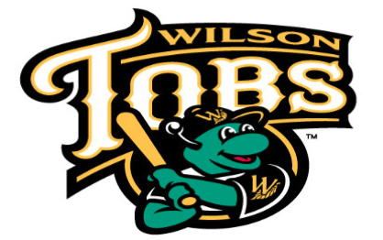
Wilson Tobs Baseball
Beer & BBQ Festival
Sanctioned
Saturday June 1, 2019

Gates open for cookers at TBD
Judging at 5:20 PM
Gates open for public at 5:45 PM
Game starts at 7:00 PM

Historic Fleming Stadium, 300 Stadium St. SW, Wilson, NC 27893

1st, 2nd, & 3rd Cash Prizes! - Only 15 spots available

APPLICATION DEADLINE: April 30th, 2019
Name of Head Cook: ___________________________________________________________
Address:
_____________________________________________________________________________________________

(Street) (City) (State) (Zip Code)

Contact Person’s Phone/Email:
____________________________________ ___________________________________________________
(Phone) (Email)

Team Sponsor, if any ______________________________ Team Name______________________________

Registration Fee: $200 per team
- 90-100lb pig dressed
- 15’ x 15’ space (location based on order of registration)
(4) General Admission tickets to the game & festival
(4) Unlimited BBQ sampling wristbands
(4) Beer sampling vouchers (ten 2 oz samples) or drink vouchers (two drinks)

Advanced Ticket Sales: Each ticket is good for admission to the Game & Festival for unlimited BBQ tasting and (1) beer sampling voucher (ten 2 oz samples) or drink voucher (two drinks). Tickets at gate will be:
# Tickets Price
Adults ________ x $14 = $_______
(6-12) Kids ________ x $9 = $_______
$_______ Total
Make checks payable to: Wilson Tobs Baseball, Beer & BBQ Festival, 300 Stadium St. SW, Wilson NC 27893
Registration $________

Tickets $________

TOTAL FEES $________

MasterCard & Visa accepted:
Card # __________________________________________ Exp. Date _________
Name on Card (print) _________________________________________________ CVV___________
Signature ______________________________________________________________

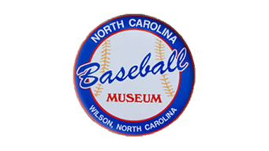
Questions? Call 252-291-8627 or email mike@wilsontobs.com
