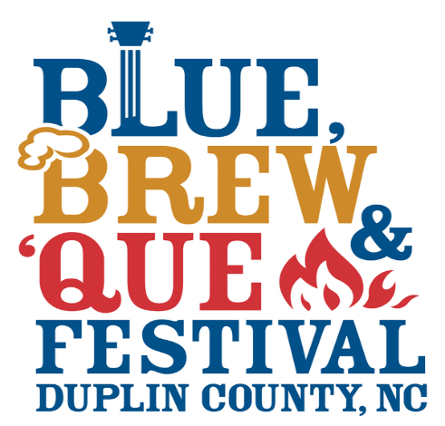
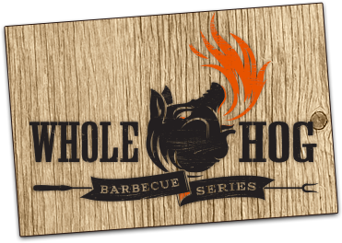

Team Information:

Team Name
____________________________________________________________________________
Chief Cook ___________________________________________________________________
(All correspondence will be with the Chief Cook)
Address ___________________________________________ Email _____________________
City _______________________________________________ State______ Zip____________
Telephone (Home) ___________________________________ (Cell) _____________________
Assistant Cooks: (Minimum of 1, Maximum of 3)
1.
______________________________________________________________________________
2.
______________________________________________________________________________
3.
______________________________________________________________________________
Space Information:
Each team will be allocated one 12x20 outside space. Each team must provide their own shelter if desired. If you require a larger cooking area, describe in detail your reasons, including sizes of grills, props, and any other items used in cooking set-up. Attach additional sheet, if needed.
________________________________________________________________________________
________________________________________________________________________________
________________________________________________________________________________
Payment Information:
A $100.00 NON-REFUNDABLE entry fee must be received with each entry form no later than Feb. 1st. The contest is limited to 20 teams; entries will be accepted on a first-come, first serve basis. The committee reserves the right to reject any entry. If entry is not accepted, your $100 entry fee will be refunded.
______________________________________________________________________________
In consideration of the acceptance of this entry, I forever release the Blue, Brew, & Que Festival and all sponsors and organizers of the festival and the “Blue, Brew, & Que Cook-Off” of all claims, damages, injury, death and rights of action present or future whatsoever for my participation in this event. The Blue, Brew, & Que Festival reserves the right to rectify the application as needed.
I have read and agree to abide by all Rules and Regulations of the Blue, Brew, & Que Cook-Off Contest.
___________________________
Chief Cook Signature
___________________________
Date
Return with check payable to Duplin County Agri-Community Center Foundation no later than Thursday, February 1st, 2018.

Mail to: Blue, Brew, & Que Festival
C/O Duplin County Events Center
195 Fairgrounds Dr.
Kenansville, NC 28349

