Rivertown Smoke Show BBQ Cook Off---Cooker Application for October 7th & 8th, 2022

Entry Deadline is Friday, September 23, 2022 or until available space is filled. First received, first accepted.
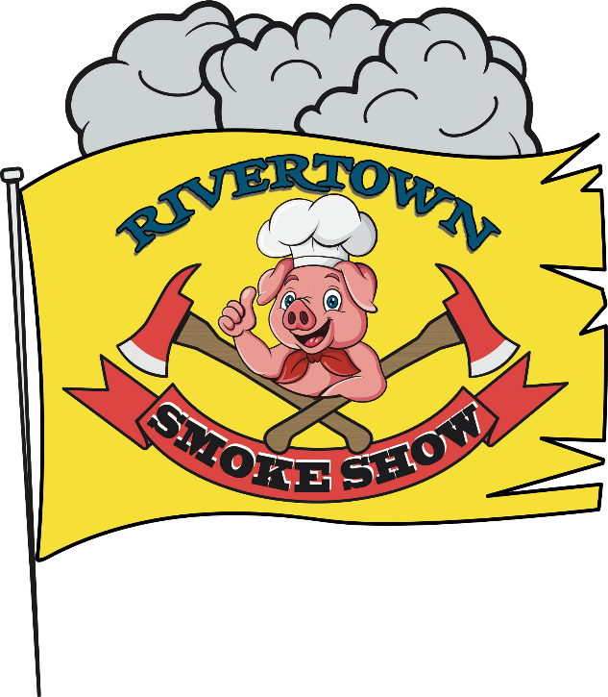

Team or Business Name:_____________________________________________________________________
Chief Cook:______________________________________________________________________________
Mailing Address: _______________________________________________________________________________
City:________________________________________ State: _____________ Zip Code: _____________________
Phone: ____________________ Fax: ___________________E-Mail Address: ______________________________
Showmanship Participant?: Y___ N___ Sponsor Name __________________________________________
Cooking with: Wood_____ Charcoal_____ Gas_____
Do you need electricity? Y____ N____ Do you have a tent? Y_____ N_____ What size?___________
Parking is limited to one parking space per team. NO RV’s that do not fit into a regular parking space.
Please contact Trey Liverman at 252-916-4486 or mailto: tyrrellvfd1@yahoo.com for further information.
Entry fee is $150
Make checks payable to: Tyrrell VFD (Attn Trey Liverman)
mail to: Tyrrell Vol Fire Dept, 91 Burton Shell Rd, Columbia, NC 27925

A CHIEF COOKS MEETING WILL TAKE PLACE AT 6 P.M. ON FRIDAY, OCTOBER 7th
Inside Tyrrell Hall @ competition location.
Whole Hog Judging begins at 8 a.m. on Saturday, Oct. 8th.

Vendors will not hold the Cook Off participants, directors, volunteers, or employees responsible for claims, losses, fees, damages, or expense. The BBQ Cook Off Committee will not refund due to inclement weather, government action, strikes, or other matters beyond its control. By signing your name below, you are stating that you have read the application and rules and that you and your organization will abide by the rules or risk being removed from the Cook Off. There will be no refunds unless non-acceptance into the Cook Off.

Signature: ______________________________________ Date: _____________________________________
Mail to: 91 Burton Shell Rd Columbia, NC 27925 Phone Number (252) 916-4486.
Rivertown Smoke Show C/O Tyrrell Vol. Fire Dept
91 Burton Shell Rd Columbia, Nc 27925
ENTRY DEADLINE IS FRIDAY, SEP. 23. ENTRIES WILL BE ACCEPTED ON A FIRST COME, FIRST SERVE BASIS. PLEASE SIGN UP AS SOON AS POSSIBLE TO GUARANTEE YOUR SPACE.

